Board members
Present: Jen Chapman, Barb Guillon, Anne Harfenist, Ali Howard, Susan Kinkela, Brandin Lilgert, Steve Osborn, Sarah Sacharoff, Stephen Wickham

Unable to attend: Hillary Clark, Kira Hoffman

Meeting started at 19:31

1) Minutes of Last Meeting

Motion: Susan moved to accept April 24 draft board meeting minutes; Ali seconded. Approved.

2) Directors Reports

Barb: Treasurer (financial reports emailed by Steve O. June 11)

Steve O: Nordic Centre (emailed June 11)

Tracksetter funding:
The new tracksetter reserve now has $55,172.
$18,982 came from previous club surpluses which first went into the garage fund and then the unspent amount was transferred into the tracksetter reserve.
$21,190 came from this year’s club fundraiser (includes $2k from a Nordiq Canada donor and a VERY generous $10k from a local donor).
$15,000 from the Nordic Centre operational budget; one of the reasons for the recent trail fee increase.

Grant applications:
We are still waiting to hear from BV Community Foundation about the $250K Community Impact Grant. 🤞
If we are successful, we could buy a very nice used machine but our plan is to first use that money as our 50% contribution in an application later this summer for a Gaming Capital Projects grant.
At the same time, Jen is leading the process for our Destination Development application. Our earlier expression of interest sought a total of $790K with $615 for groomer and attachments. 🤞
If/when we are successful with one or both grants we will figure out how to respond.

Repairs to the Old Shed and Wax Hut:
Subsequent to the update in my May 7 email, we now have a modified plan and the OK from RDBN to use our previously approved $45K gas tax grant to make critical repairs to both the wax hut and the old shed. We have a contractor lined up to do the work as soon as we get the paperwork from the regional district.

Wetzin’kwa Community Forest:
We put in an application for some FireSmart repairs/enhancements to the buildings, as I described in my May 7 email.
On May 3, Jan and I met with Wetzin’kwa Community Forest soon to discuss WCFC’s upcoming plans for Wildfire Risk Reduction on HBM and plans for summer partial-cut logging. The partial-cut logging will be small areas near the logging road trails, if the weather allows summer/fall access. No impact to winter skiing. Also planned this summer is thinning along HBM road, as shown on the attached map. They understand our interest in minimizing impacts on skiing experience while still reducing fire risk. (e.g. retaining most/all of the vegetation along the thin strip of forest between HBM road and One Click Right.)

Steve Osborn
Director – Nordic Centre Operations
Bulkley Valley Cross Country Ski Club
250-877-8595

--
A reply to this message will be sent only to the author. If you want your reply to go to all directors, put board@bvnordic.ca in the To: field
Wetzinkwa-WRR-map.jpg
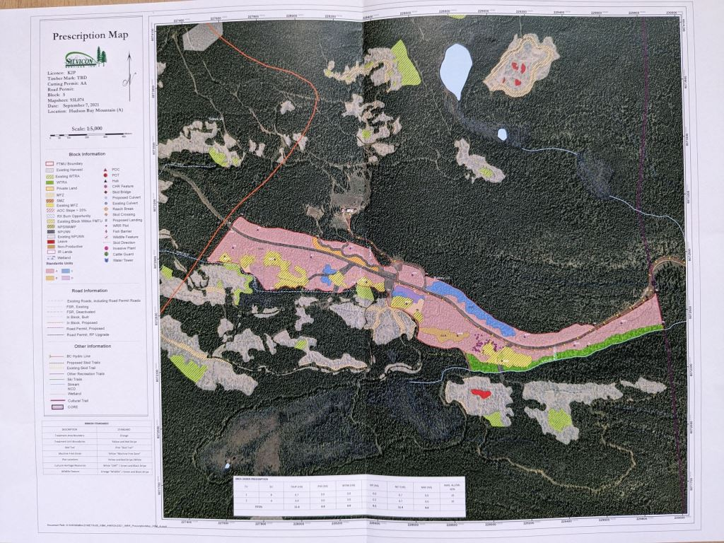

Brandin: Communications (no report)
Position open: Grants & Sponsorships
Ali: Events (no report)
Sarah: NSDP (emailed June 12)
Finances
Uncertainty still around size of NSDP surplus: (10 k - 20 k depending on unknowns)
- what we brought in for summer registration $
- still waiting for 7k from BVCF for ski s’kool grant? Have asked Barb about this. Will follow up with BVCF if Barb confirms we haven’t received.
- Reimburse Andrew (RRSP, Coaching Expenses, Travel). He is not responding
- did Biathlon do additional rifle purchases?

NSDP would like to propose we contribute $10k to NSDP reserve and $3k to Biathlon reserve. Any extra would be available for redistribution. I expect there will be extra.

- got a CCBC grant for some new roller skis (thanks Denise)

New Head Coach
- announced to NSDP and Board
- will start mid August

Summer Programming
- in full swing. Support from Chris Werrell (YTPs) and Graham MacLean (coaching).
- 5+ athletes have attended training camps in Whistler

Ski Boosters
- working with Ski Boosters to clarify scope of ski boosters responsibilities
- strategizing ways to make ski boosters more appealing to volunteer for
- Diana Cullen to look at totals for ticket checking
Anne: Secretary (no report)

3) Action Items from Previous Meeting

- those directors who have not already done so to prepare job descriptions – some still outstanding
- Susan to provide recommendation wrt permanent passes to board sometime within next month or two – not yet done
- Jen to see if bank loan is even a possibility – it is a possibility but paused because need consultation with Edmisson Mehr
- Kira to share findings on subject of higher rates with Barb
- Brandin and maybe Steve W. to work with Steve O., provide input into budgeting
- Anne to write article about rejection of swamp dog proposal – done; decision made to delay inclusion in newsletter until fall
- Sarah to adapt Code of Conduct and send draft to Kira and Ali for review

4) New/Continuing Business

- Identifying program surpluses/deficits and deciding what to move to/from reserve funds

Motion: Steve O. moved that $55,000 be put into a restricted reserve for the purpose of purchasing a tracksetter and associated costs within the next 3 years; Anne seconded. Approved.

- still ongoing consideration of what can we do to maximize the return on our reserves
- Note that NDIT offers loans for situations where funder not pay until after money is spent
- events surplus not yet finalized

Motion: Ali moved that any surplus from events be put into an events reserve; Susan seconded. Approved.

- Many uncertainties for NSDP so want to wait for final numbers
- Support from board for proposal to put $10,000 into NSDP reserve and $3,000 into biathlon reserve; to be confirmed by motion if final numbers warrant at next board meeting
- Defer discussion of restricted memorial reserve

Future action item: recalculate what our targets for reserves are.

Motion: Steve O. moved to shift money from the infrastructure contingency reserve to cover the Nordic Centre deficit; Ali seconded. Approved.

- Consider season pass fee increase
- Need to know fee by September
- Suggestions included increase of 3% per year, no increase this year until have better look at Nordic Centre budget, rate go up by cost of living
- Discussion about what to do about day fee/season pass balance
- A request to itemize zone 4 fees in budget; lack of transparency noted

Motion: Steve W. moved that the club increase the seasons pass fee annually in line with the annual consumer price index unless the board chooses to defer an increase; Sarah seconded. Approved – not unanimous.

- Destination Grant application
- Discussion to identify minimum priorities

- Code of Conduct review
- Discussed adding some guidance for when code of conduct is broken
- Discussed extending code to all members not just ADP and coaches
- Define major and minor infractions – different consequences, differ in who deals with them
- Other clubs have examples
- Should it apply outside of NSDP?
- Aim to have ready for next season
Action Item: Sarah to adapt Code of Conduct and send draft to Kira and Ali for review

At this point, the meeting was moved in camera.
Meeting adjourned at 20:45.

